COLOR-CODE STANDARDS
Last updated: 5/20/2002
Again, please bear with me... Let's start with simple pin-out diagrams of the two types of UTP Ethernet cables and watch how committees can make a can of worms out of them. Here are the diagrams:

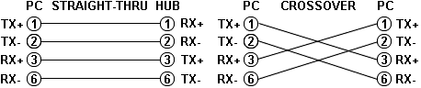

Note that the TX (transmitter) pins are connected to corresponding RX (receiver) pins, plus to plus and minus to minus. And that you must use a crossover cable to connect units with identical interfaces. If you use a straight-through cable, one of the two units must, in effect, perform the cross-over function.
Two wire color-code standards apply: EIA/TIA 568A and EIA/TIA 568B. The codes are commonly depicted with RJ-45 jacks as follows:

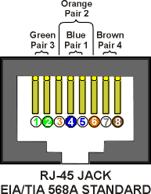 | 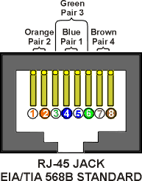
If we apply the 568A color code and show all eight wires, our pin-out looks like this:

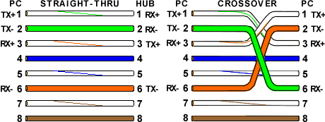

Note that pins 4, 5, 7, and 8 and the blue and brown pairs are not used in either standard. Quite contrary to what you may read elsewhere, these pins and wires are not used or required to implement 100BASE-TX duplexing--they are just plain wasted.
However, the actual cables are not physically that simple. In the diagrams, the orange pair of wires are not adjacent. The blue pair is upside-down. The right ends match RJ-45 jacks and the left ends do not. If, for example, we

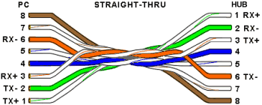

invert the left side of the 568A "straight"-thru cable to match a 568A jack--put one 180° twist in the entire cable from end-to-end--and twist together and rearrange the appropriate pairs, we get the following can-of-worms:

This further emphasizes, I hope, the importance of the word "twist" in making network cables which will work. You cannot use an flat-untwisted telephone cable for a network cable. Furthermore, you must use a pair of twisted wires to connect a set of transmitter pins to their corresponding receiver pins. You cannot use a wire from one pair and another wire from a different pair.

Keeping the above principles in mind, we can simplify the diagram for a 568A straight-thru cable by untwisting the wires, except the 180° twist in the entire cable, and bending the ends upward. Likewise, if we exchange the green and orange pairs in the 568A diagram we will get a simplified diagram for a 568B straight-thru cable. If we cross the green and orange pairs in the 568A diagram we will arrive at a simplified diagram for a crossover cable. All three are shown below.

12345678 12345678 | 12345678 12345678 | 12345678 12345678
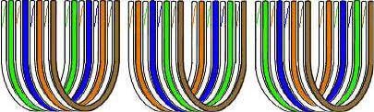
STRAIGHT-THRU  568A | STRAIGHT-THRU  568B | CROSSOVER  568A TO 568B

